When repealing complete section, history note has blank spaces for date of repeal and authority citation is removed.

Header: Register number and AAC volume title

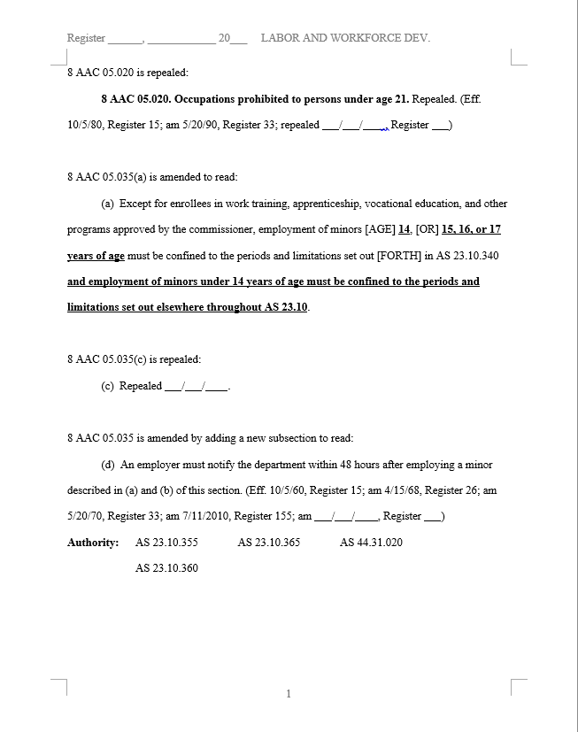

New text is bolded and underlined; deleted text is bracketed and capitalized.

Blanks provided for date of repeal.

When adding a completely new provision, no bold or underline on added text.

Footer: page number

History note shows repeal of paragraph as an "amendment," because the section remains. Repeals within a section are always shown as amendments; only the repeal of a complete section results in "repeal" notation in the history note.

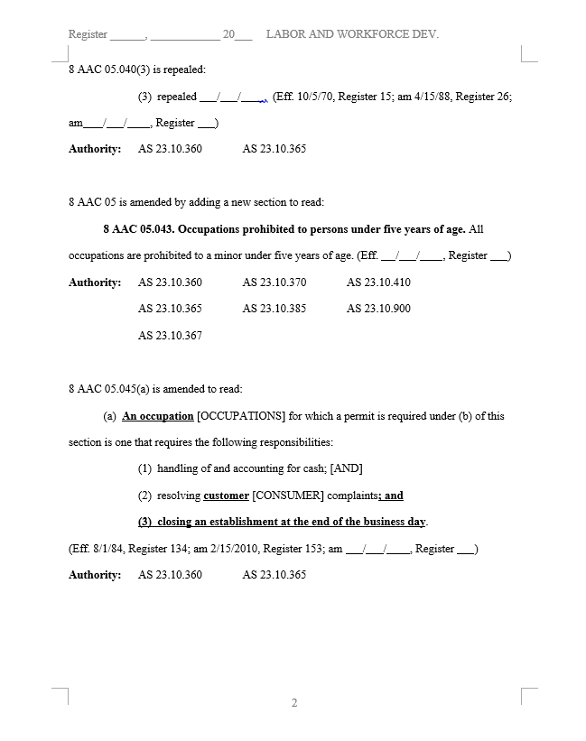

Because no subdivisions follow this new section, history note begins immediately after text on same line.

Because subsection (a) is followed by other subdivisions not being amended, history note begins on next line down.

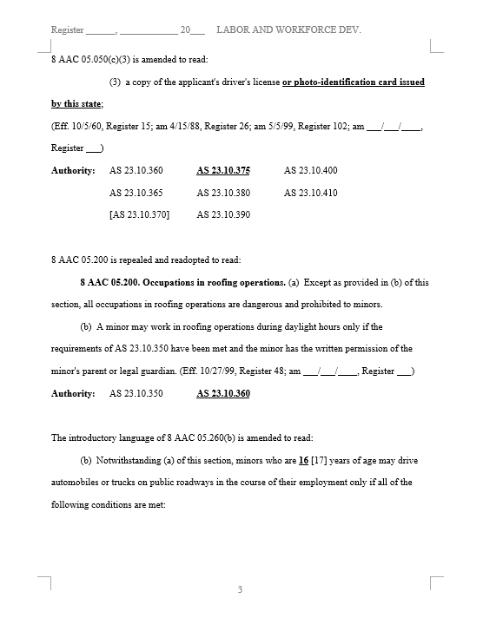

Amendments to authority citation are shown in standard amendment format; layout remains in numerical order.

Lead-in line indicates that only "introductory language" is amended because there are no amendments made to the paragraphs of (b).

In this type of amendment, ellipses indicate that subdivisions follow that are not being amended. Ellipses should be bolded and in 16pt font.

**…**

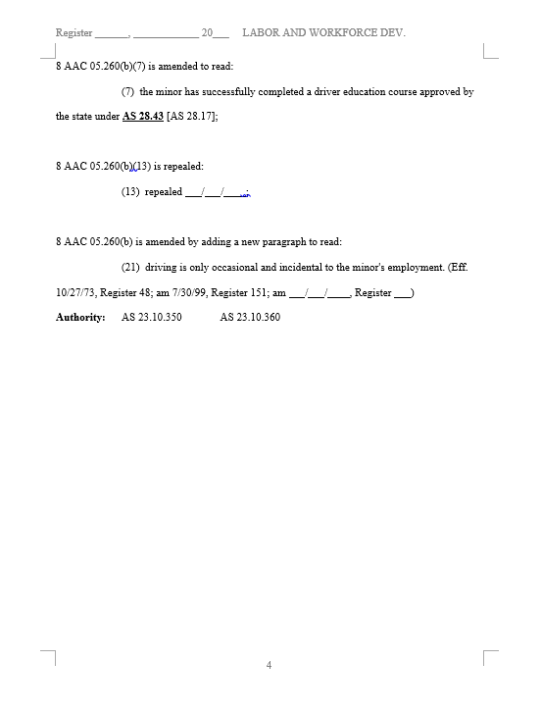

Amendment is made to entire span of citation, not just chapter. Amendments must always be to entire span of citation or to entire word.

Authority citation is only set out once—at the end of the amendments to the section (in this example, at the end of the amendments to .260)